**Green Sort**

Submitted in partial fulfillment of the requirements

of the Mini-Project 1-B for Second Year of

**Bachelors of Engineering**

By

|  |  |  |
| --- | --- | --- |
| SRIVASTAVA SAGARIKA SHEKHAR | 231P047 | * 44 |
| SHAIKH SIDRA AMJAD ALI | 231P064 | * 40 |
| ANSARI BUSHRA ZAHIRUDDIN | 231P046 | * 03 |
| SOLKAR SIDRA SAMEER | 231P087 | * 43 |

Guide: PROF. RESHMA LOHAR



**Department of Computer Engineering**

**Rizvi College of Engineering**



**University of Mumbai**

**2024-2025**

**CERTIFICATE**

This is to certify that the mini-project entitled “**Green Sort - IoT Device for Garbage Segregation”** Bonafide work of

|  |  |  |
| --- | --- | --- |
| SRIVASTAVA SAGARIKA SHEKHAR | 231P047 | 44 |
| SHAIKH SIDRA AMJAD ALI | 231P064 | 40 |
| ANSARI BUSHRA ZAHIRUDDIN | 231P046 | 03 |
| SOLKAR SIDRA SAMEER | 231P087 | 43 |

submitted to the University of Mumbai in partial fulfillment of the requirement for the Mini-Project 1-B for Second Year of the Bachelor of Engineeringin **“Computer Engineering”**.

_______________ _______________

PROF. RESHMA LOHAR **External Examiner**

**Guide**

_______________ ______________

DR. ANUPAM CHOUDHARY Dr. Varsha Shah

**Head of Department** **Principal**

**DECLARATION**

We declare that this written submission represents our ideas in our own words and where others' ideas or words have been included, we have adequately cited and referenced the original sources. We also declare that We have adhered to all principles of academic honesty and integrity and have not misrepresented or fabricated or falsified any idea/data/fact/source in our submission. We understand that any violation of the above will be cause for disciplinary action by the Institute and can also evoke penal action from the sources which have thus not been properly cited or from whom proper permission has not been taken when needed.

---------------------------------------------------------------SRIVASTAVA SAGARIKA SHEKHAR – 44 – 231P047

---------------------------------------------------------------

SHAIKH SIDRA AMJAD ALI – 40 – 231P064

ANSARI BUSHRA ZAHIRUDDIN – 03 – 231P046

---------------------------------------------------------------

SOLKAR SIDRA SAMEER – 43 – 231P087

Date: 03/04/2025

**ABSTRACT**

**“Green Sort”** is an IoT-based Wet and Dry Waste Segregation Device is an intelligent system designed to automate the classification of waste into wet (organic) and dry (inorganic) categories using advanced sensor technology and machine learning. The device employs moisture sensors, infrared sensors, gas sensors, and image recognition to accurately identify waste types and direct them into the appropriate bins using motorized flaps.

Integrated with microcontrollers such as Arduino, the system processes real-time data and transmits waste analytics to a cloud-based platform for monitoring and optimization. Wireless connectivity via Wi-Fi allows remote tracking of waste levels and timely collection alerts through a mobile or web-based interface.

By enhancing waste segregation efficiency, reducing human effort, and promoting recycling, this IoT solution contributes to sustainable waste management in smart cities, households, industries, and public spaces.

**KEYWORDS:** SENSOR TECHNOLOGY, SUSTAINABLE WASTE SEGREGATION AND MANAGEMENT, RECYCLING, AUTOMATION, SMART BINS.

**INDEX**

|  |  |  |  |  |  |  |  |  |
| --- | --- | --- | --- | --- | --- | --- | --- | --- |
| SR.  NO. | TITLE | | | | | | | PAGE  NO. |
| 1. | Introduction | | | | | | |  |
|  | 1.1 | The Growing Challenge of Waste Management | | | | | | 9 |
|  | 1.2 | Introducing Green Sort: An IoT-Based Waste Segregation Solution | | | | | |  |
|  | 1.3 | Key Features of Green Sort | | | | | | 10 |
|  |  | 1.3.1 | | | Advanced Sensor Technology | | |  |
|  |  | 1.3.2 | | | Automated Waste Sorting with Motorized Flaps | | |  |
|  |  | 1.3.3 | | | Integration with Microcontrollers for Real-Time Processing | | |  |
|  |  | 1.3.4 | | | Cloud-Based Monitoring and Data Analytics | | |  |
|  |  | 1.3.5 | | | Connectivity for Remote Tracking | | |  |
|  | 1.4 | Applications of Green Sort in Various Sectors | | | | | | 11 |
|  | 1.5 | Environmental and Economic Benefits of Green Sort | | | | | | 12 |
|  |  | 1.5.1 | | | | Promoting Sustainability and Recycling | |  |
|  |  | 1.5.2 | | | | Reducing Landfill Overload and Pollution | |  |
|  |  | 1.5.3 | | | | Minimizing Human Effort and Health Risks | |  |
|  |  | 1.5.4 | | | | Cost Savings and Operational Efficiency | |  |
|  | 1.6 | The Future of Smart Waste Management with IoT | | | | | | 13 |
| 2. | Review and Literature | | | | | | | 14 |
|  | 2.1 | Waste Segregation and its Importance | | | | | |  |
|  |  | 2.1.1 | | | | | Challenges in Traditional Waste Segregation |  |
|  |  | 2.1.2 | | | | | Benefits of Automated Waste Segregation |  |
|  | 2.2 | IoT-Based Waste Management Systems | | | | | |  |
|  |  | 2.2.1 | | | | | Role of IoT in Smart Waste Management |  |
|  |  | 2.2.2 | | | | | Sensor Technology in Waste Classification |  |
|  |  | 2.2.3 | | | | | Machine Learning for Waste Classification |  |
|  | 2.3 | Cloud-Based Monitoring and Waste Analytics | | | | | |  |
|  |  | 2.3.1 | | | | | Real-Time Data Processing for Smart Waste Management |  |
|  |  | 2.3.2 | | | | | Wireless Connectivity for Remote Tracking |  |
|  | 2.4 | Sustainability and Environmental Impact | | | | | |  |
|  |  | 2.4.1 | | Reducing Landfill Waste and Promoting Recycling | | | |  |
|  |  | 2.4.2 | | Economic and Environmental Benefits | | | |  |
|  | 2.5 | Gaps in Existing Research and Future Scope | | | | | |  |
| 3. | Theory, Methodology and Algorithm | | | | | | | 18 |
|  | 3.1 | Theory Behind Green Sort | | | | | |  |
|  |  | 3.1.1 | Principles of Waste Segregation | | | | |  |
|  |  | 3.1.2 | Role of IoT and Cloud Computing | | | | |  |
|  | 3.2 | Methodology | | | | | |  |
|  |  | 3.2.1 | System Architecture | | | | |  |
|  |  | 3.2.2 | Hardware Components | | | | |  |
|  |  | **3.2.3** | Software Components | | | | |  |
|  | 3.3 | Data Processing Workflow | | | | | |  |
| 4. | Results and Discussions | | | | | | | 22 |
|  | 4.1 | Experimental Setup | | | | | |  |
|  | 4.2 | Results | | | | | |  |
|  |  | 4.2.1 | Waste Classification Accuracy | | | | |  |
|  |  | 4.2.2 | Response Time Analysis | | | | |  |
|  |  | 4.2.3 | IoT-Based Monitoring Efficiency | | | | |  |
|  | 4.3 | Discussions | | | | | |  |
|  |  | 4.3.1 | Comparison with Existing Waste Segregation Methods | | | | |  |
|  |  | 4.3.2 | Advantages of Green Sort | | | | |  |
|  |  | 4.3.3 | Challenges and Limitations | | | | |  |
|  |  | 4.3.4 | Future Improvements | | | | |  |
| 5. | Conclusion | | | | | | | 28 |
| 6. | References | | | | | | | 29 |
| 7. | Appendix | | | | | | | 30 |
| 8. | Acknowledgement | | | | | | | 33 |
| 9. | Publication | | | | | | | 34 |

**LIST OF FIGURES**

|  |  |  |
| --- | --- | --- |
| Sr. No | Title | Page No |
|  |  |  |
|  |  |  |
|  |  |  |
|  |  |  |

**LIST OF TABLES**

|  |  |  |
| --- | --- | --- |
| Sr. No | Title | Page No |
| 1.1 | Sensor and Machine Accuracy | 23 |
| 1.2 | Average Response Time Analysis | 24 |
| 1.3 | Success Rate | 25 |
| 1.4 | Sensor Based Segregation | 26 |
| 2.1 | Hardware Components Used | 30 |
| 2.2 | Software and Algorithms Used | 31 |
| 2.3 | Experimental Waste Samples Used | 32 |

**CHAPTER 1**

**INTRODUCTION**

* 1. **The Growing Challenge of Waste Management**

As urbanization, industrialization, and population growth accelerate worldwide, waste generation has surged to unprecedented levels. Millions of tons of waste are produced daily, straining existing disposal and recycling systems. Inefficient waste management leads to severe environmental consequences, including air and water pollution, greenhouse gas emissions, and the depletion of natural resources. A significant contributor to this crisis is the improper segregation of waste, which hampers recycling efforts, increases landfill accumulation, and poses serious health hazards.

Traditional waste segregation relies heavily on human effort, which is often inconsistent, time-consuming, and error-prone. Many households, industries, and public spaces fail to properly separate wet (organic) and dry (inorganic) waste, resulting in mixed waste that is difficult to process. Consequently, recyclable materials often end up in landfills, and organic waste is lost instead of being composted efficiently. To address these inefficiencies, there is a pressing need for automated, intelligent waste management solutions that can streamline waste segregation at the source.

* 1. **Introducing Green Sort: An IoT-Based Waste Segregation Solution**

Green Sort is a cutting-edge IoT-based Wet and Dry Waste Segregation Device that leverages advanced sensor technology and machine learning to revolutionize the waste management process. Designed to automate the classification and segregation of waste, this innovative system ensures precise sorting, minimizes human intervention, and enhances recycling efficiency. By integrating real-time data processing, cloud-based analytics, and wireless connectivity, Green Sort provides a smart and sustainable approach to waste disposal.

* 1. **Key Features of Green Sort**
     1. **Advanced Sensor Technology:**Green Sort utilizes a combination of moisture sensors, infrared sensors, gas sensors, and image recognition to accurately identify and classify waste.
  2. Moisture sensors detect the presence of liquid content to differentiate between wet and dry waste.
  3. Infrared sensors help identify material composition by analysing reflectivity properties.
  4. Gas sensors detect the presence of organic compounds to confirm biodegradability.
  5. Image recognition enables visual classification of waste items, further refining segregation accuracy.
     1. **Automated Waste Sorting with Motorized Flaps**  
        Upon classification, the system directs the waste into the appropriate bin using motorized flaps, ensuring seamless separation of wet and dry waste without manual effort. This automated sorting mechanism reduces contamination and enhances the efficiency of downstream recycling processes.
     2. **Integration with Microcontrollers for Real-Time Processing**  
        Powered by microcontrollers such as Arduino, Green Sort efficiently processes sensor data, enabling real-time decision-making and waste classification. This embedded system ensures smooth operation, fast processing, and reliable performance in diverse environments.
     3. **Cloud-Based Monitoring and Data Analytics**

The device transmits waste analytics to a cloud-based platform, allowing authorities, households, and waste management agencies to monitor waste generation patterns. The system provides data-driven insights that can optimize waste collection schedules, predict trends, and improve recycling rates.

* + 1. **Connectivity for Remote Tracking**Green Sort features Wi-Fi connectivity, enabling users to track waste levels remotely. Through a mobile or web-based interface, real-time updates, alerts, and notifications can be accessed, ensuring timely waste collection and maintenance. This feature is particularly useful for municipalities, industries, and large public spaces where efficient waste management is crucial.
  1. **Applications of Green Sort in Various Sectors**

1. **Smart Cities**
   1. Enhances urban waste management by automating segregation at public waste bins.
   2. Reduces landfill waste and encourages recycling in city-wide waste collection programs.
2. **Households and Residential Areas**
   1. Simplifies waste segregation for homeowners, promoting responsible disposal habits.
   2. Reduces reliance on waste pickers and manual sorting, leading to a cleaner environment.
3. **Industries and Commercial Spaces**
   1. Helps businesses comply with waste management regulations by ensuring proper segregation at the source.
   2. Optimizes waste disposal processes, reducing operational costs.
4. **Public Spaces and Institutions**
   1. Ideal for schools, hospitals, shopping malls, and offices to manage waste efficiently.
   2. Reduces waste contamination and promotes sustainable waste disposal practices.

**1.5 Environmental and Economic Benefits of Green Sort**

**1.5.1 Promoting Sustainability and Recycling**

By ensuring proper segregation of waste at the source, Green Sort significantly enhances recycling efficiency. When dry waste such as plastics, metals, and paper is separated from organic waste, it can be easily processed and reused, reducing the need for virgin materials. Likewise, wet waste can be directed toward composting or bio-energy production, minimizing landfill dependency.

**1.5.2 Reducing Landfill Overload and Pollution**

Improperly mixed waste leads to landfill overflow, releasing harmful greenhouse gases such as methane and carbon dioxide. By preventing mixed waste disposal, Green Sort plays a crucial role in reducing landfill waste, thus lowering environmental pollution and carbon footprints.

**1.5.3** **Minimizing Human Effort and Health Risks**

Traditional waste segregation methods often expose workers to hazardous materials and health risks. By automating the process, Green Sort reduces human contact with waste, ensuring safer and more hygienic waste handling. This not only benefits waste collectors but also helps in maintaining clean and sanitary public spaces.

**1.5.4 Cost Savings and Operational Efficiency**

Municipalities and waste management companies can optimize waste collection schedules by leveraging Green Sort’s real-time data analytics. This reduces unnecessary waste collection trips, saving fuel, labour costs, and operational expenses.

**1.6 The Future of Smart Waste Management with IoT**

With the global push toward sustainable development and smart city initiatives, IoT-based solutions like Green Sort represent the future of intelligent waste management. The integration of automation, cloud computing, and data-driven decision-making ensures a more efficient, eco-friendly, and technologically advanced approach to waste disposal.

As more cities, industries, and institutions adopt smart waste management technologies, innovations like Green Sort will play a pivotal role in reducing environmental impact, improving recycling rates, and fostering a culture of responsible waste disposal. By harnessing the power of IoT and artificial intelligence, Green Sort offers a scalable and adaptable solution that paves the way for a cleaner, greener, and smarter world.

**CHAPTER 2**

**REVIEW OF LITERATURE**

Waste management has been a critical area of research, particularly in the context of rapid urbanization and industrialization. Traditional waste disposal methods have proven ineffective in handling the increasing volume of waste, leading to environmental hazards and inefficiencies in recycling processes. Recent studies have explored the role of IoT, sensor technology, and machine learning in automating waste segregation and optimizing waste collection systems. This review of literature examines existing research on automated waste segregation, IoT-based waste management, and sustainable waste disposal techniques, providing a foundation for understanding the development of Green Sort, an IoT-based wet and dry waste segregation device.

**2.1 Waste Segregation and its Importance**

**2.1.1 Challenges in Traditional Waste Segregation**

Several studies have highlighted the inefficiencies of manual waste segregation. They pointed out that manual sorting is often inconsistent and labour-intensive, leading to improper classification of waste. Similarly, It was noted that lack of awareness and inadequate waste disposal infrastructure further contribute to the mixing of wet and dry waste, making recycling less effective.

**2.1.2 Benefits of Automated Waste Segregation**

Research conducted demonstrated that automated waste segregation significantly improves the efficiency of waste management systems. By using sensor-based technologies, waste classification accuracy can be enhanced, leading to better recycling rates and reduced landfill waste. Studies also indicate that automation reduces human intervention, minimizing the health risks associated with waste handling.

**2.2 IoT-Based Waste Management Systems**

**2.2.1 Role of IoT in Smart Waste Management**

The Internet of Things (IoT) has been increasingly explored for waste monitoring and segregation. IoT-based waste management systems enable real-time data collection, allowing for efficient monitoring of waste levels, optimized collection schedules, and predictive analytics. Another study emphasized that cloud-based waste management platforms help municipalities and industries track waste generation patterns and improve disposal strategies.

**2.2.2 Sensor Technology in Waste Classification**

Recent advancements in sensor technology have enhanced the accuracy of automated waste identification. Researchers have explored the application of moisture sensors, infrared sensors, and gas sensors in distinguishing between organic (wet) and inorganic (dry) waste. Their findings indicate that moisture sensors are effective in detecting liquid content, while infrared sensors play a key role in identifying plastic, metal, and paper waste. Additionally, gas sensors have been used to identify organic compounds, making them useful in detecting biodegradable materials.

**2.2.3 Machine Learning for Waste Classification**

Several studies have integrated machine learning algorithms into waste classification systems. Image recognition technology can classify waste based on shape, colour, and texture, improving the sorting efficiency. Machine learning models such as convolutional neural networks (CNNs) and deep learning algorithms have been employed to enhance image-based waste classification accuracy.

**2.3. Cloud-Based Monitoring and Waste Analytics**

**2.3.1 Real-Time Data Processing for Smart Waste Management**

The integration of cloud computing in waste management has been widely studied. Cloud-based platforms facilitate real-time waste data processing, allowing stakeholders to monitor and analyse waste trends. This helps in optimizing waste collection routes and schedules, reducing operational costs for municipalities and waste management companies.

**2.3.2 Wireless Connectivity for Remote Tracking**

IoT-enabled wireless communication technologies such as Wi-Fi have been widely adopted in smart waste management solutions. A study examined the efficiency of wireless sensors in transmitting waste bin data to cloud platforms, ensuring timely collection and reducing overflowing bins. These findings support the implementation of remote tracking systems in Green Sort, allowing users to monitor waste levels through a web-based interface.

**2.4 Sustainability and Environmental Impact**

**2.4.1 Reducing Landfill Waste and Promoting Recycling**

One of the primary objectives of automated waste segregation is minimizing landfill waste. It was emphasized that proper segregation at the source enhances recycling rates and reduces the burden on landfills. Green technologies, such as composting of organic waste and upcycling of dry waste, contribute to a more sustainable waste management system.

**2.4.2 Economic and Environmental Benefits**

Researchers highlighted that smart waste management solutions result in cost savings, resource optimization, and lower carbon footprints. IoT-enabled waste segregation reduces transportation costs, minimizes waste processing expenses, and contributes to environmental conservation.

**2.5. Gaps in Existing Research and Future Scope**

While previous studies have extensively explored sensor-based waste segregation, machine learning, and IoT-enabled waste tracking, there are still areas that require further research:

1. **Integration of Multiple Sensors for Improved Accuracy** – Most studies focus on individual sensor applications rather than integrating multiple sensor types for enhanced classification. Green Sort addresses this gap by combining moisture, infrared, gas, and image recognition sensors for precise waste identification.
2. **Scalability and Deployment in Large-Scale Environments** – Many existing waste segregation models are tested only in controlled environments. Further research is needed to evaluate their performance in large-scale urban settings, such as smart cities and industrial zones.
3. **User Awareness and Adoption Challenges** – While smart waste segregation devices offer numerous benefits, public acceptance and adoption remain challenges. Future studies should explore behavioural factors influencing the adoption of automated waste segregation systems.

**CHAPTER 3**

**THEORY, METHODOLOGY AND ALGORITHM**

**3.1 Theory Behind Green Sort**

The Green Sort IoT-based Wet and Dry Waste Segregation Device is built on the principles of sensor-based detection, machine learning classification, and automated waste management. The system relies on a combination of physical properties analysis, image processing, and IoT connectivity to classify waste accurately.

**3.1.1 Principles of Waste Segregation**

Waste is generally categorized into **wet (organic)** and **dry (inorganic)** waste based on:

1. **Moisture Content:** Organic waste typically has high moisture content, while dry waste consists of materials like plastics, metals, and paper.
2. **Material Composition:** Infrared sensors help distinguish between various materials by analyzing their reflectivity properties.
3. **Odor/Gas Emission:** Organic waste emits gases like methane and ammonia, which can be detected using gas sensors.
4. **Visual Identification:** Image recognition techniques, powered by machine learning, help identify waste items based on texture, colour, and shape.

**3.1.2 Role of IoT and Cloud Computing**

IoT technology enhances the system by enabling real-time monitoring and data analysis. The integration of Wi-Fi-enabled microcontrollers (Arduino) allows remote tracking of waste levels. Additionally, cloud computing is used to store and analyse waste data, optimizing collection schedules and promoting data-driven waste management strategies.

**3.2 Methodology**

The development of Green Sort involves a structured methodology that includes system design, hardware integration, machine learning implementation, and cloud connectivity.

**3.2.1 System Architecture**

The device consists of:

1. **Input Layer:** Waste detection through multiple sensors (moisture, infrared, gas, and camera-based image recognition).
2. **Processing Layer:** Data is processed in real-time using a microcontroller (Arduino).
3. **Decision Layer:** Machine learning models classify the waste type.
4. **Action Layer:** Motorized flaps direct waste into appropriate bins based on classification.
5. **Monitoring Layer:** IoT connectivity transmits waste data to a cloud-based platform for remote tracking.

**3.2.2 Hardware Components**

1. **Moisture Sensor:** Detects the water content in waste.

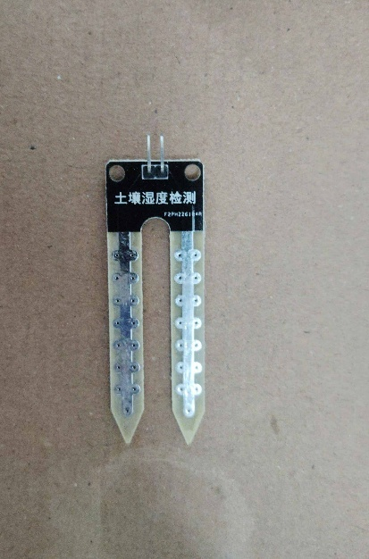

**Fig 1:** Soil Moisture Sensor

1. **Infrared Sensor:** Identifies material composition.

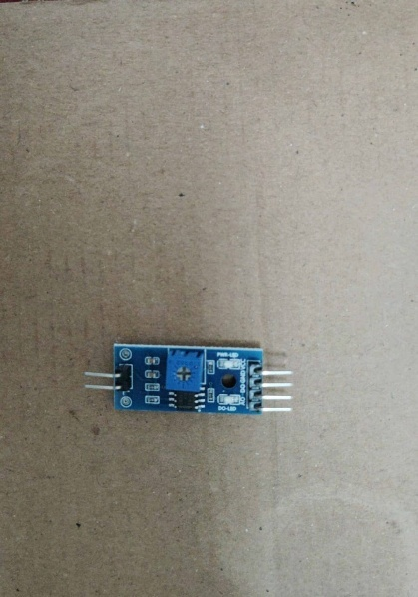

**Fig 2:** Infrared Sensor

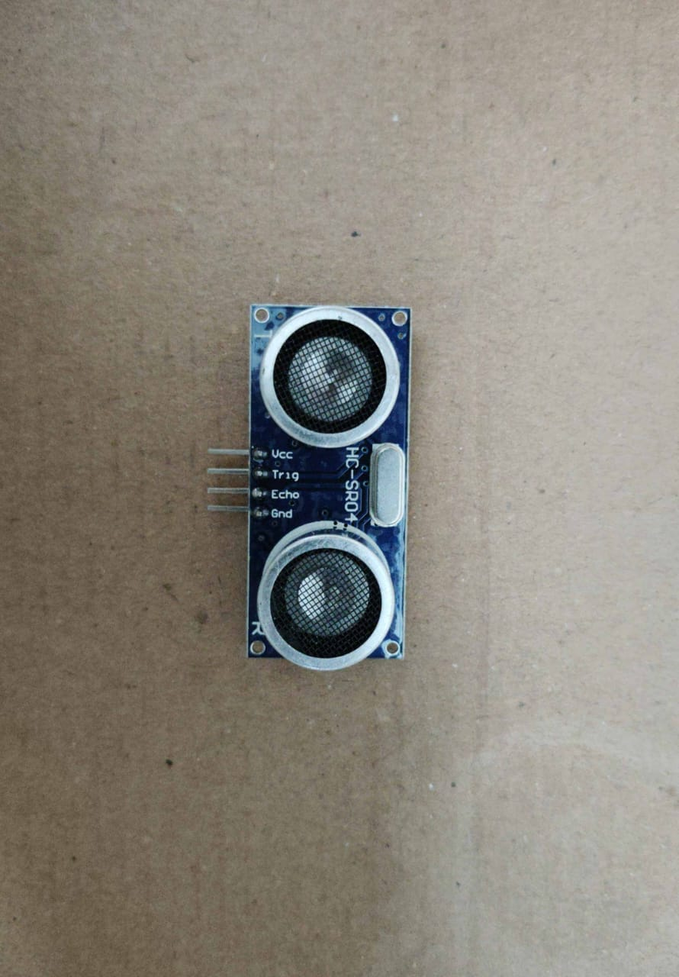

**Fig 3:** Ultrasonic Sensor

1. **Gas Sensor:** Detects volatile organic compounds emitted by wet waste.
2. **Camera Module:** Captures images for machine learning-based classification.
3. **Microcontroller (Arduino):** Processes sensor data and controls motorized flaps.

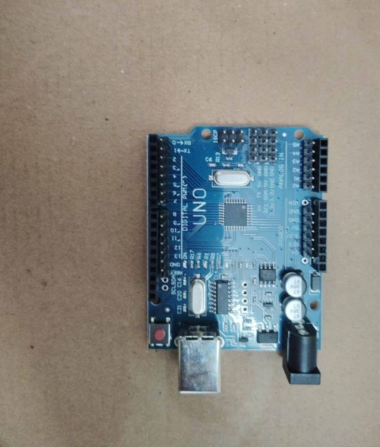

**Fig 4:** Arduino UNO

1. **Wi-Fi Module:** Facilitates cloud communication and remote monitoring.
2. **Motorized Flaps:** Physically direct waste into wet or dry bins based on classification.

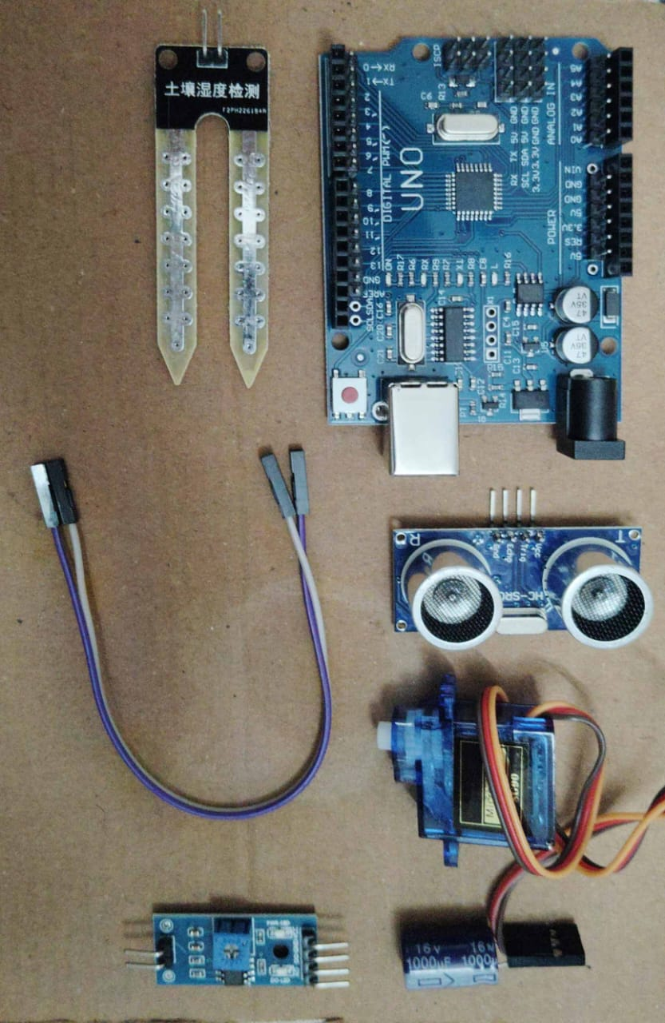

**Fig 5**: Hardware Components

**3.2.3 Software Components**

1. **Python/C++ for Microcontroller Programming:** Controls sensor inputs, processes data, and triggers bin mechanisms.
2. **Machine Learning Model:** Uses Convolutional Neural Networks (CNNs) for image-based waste classification.
3. **Cloud Platform (AWS IoT):** Stores and analyses waste data.
4. **Web Interface:** Displays real-time waste levels and collection alerts.

**3.3 Data Processing Workflow**

1. **Waste Detection:** Sensors collect data when waste is placed inside the device.
2. **Feature Extraction:**
   1. Moisture sensor determines wetness.
   2. Infrared sensor assesses material reflectivity.
   3. Gas sensor detects organic decomposition gases.
   4. Camera module captures images for machine learning analysis.
3. **Classification:** Sensor data is processed using predefined thresholds, and image data is classified using a trained neural network.
4. **Sorting Mechanism:** Based on classification results, motorized flaps direct waste into the correct bin.
5. **Cloud Synchronization:** Data is sent to the cloud for monitoring and analytics.

**CHAPTER 4**

**RESULTS AND DISCUSSIONS**

The Green Sort IoT-based Wet and Dry Waste Segregation Device was developed and tested to evaluate its efficiency in classifying waste into wet (organic) and dry (inorganic) categories. The system integrates sensor-based detection, machine learning algorithms, and IoT connectivity to ensure real-time waste segregation and monitoring. This section presents the experimental results, system performance analysis, and discussions on the effectiveness of the proposed waste segregation system.

**4.1 Experimental Setup**

The prototype was tested under controlled laboratory conditions using different waste samples. The key parameters used for evaluation included:

1. Accuracy of waste classification using sensor-based and machine learning methods.
2. Response time of the system from waste detection to sorting.
3. Effectiveness of IoT-based monitoring and notifications.
4. Moisture Sensor (for detecting wet waste).
5. Infrared Sensor (for distinguishing materials like plastic, metal, and paper).
6. Gas Sensor (for detecting organic decomposition gases).
7. Camera Module (for image-based waste classification).
8. Arduino Microcontroller (for sensor data processing).
9. Motorized Flaps (for waste sorting).
10. Wi-Fi Module (for cloud communication).

**4.2. Results**

**4.2.1 Waste Classification Accuracy**

The waste samples were tested using both sensor-based detection and machine learning image classification. The classification accuracy results are summarized below:

| Waste Type | Sensor-Based Accuracy (%) | Machine Learning Accuracy (%) |
| --- | --- | --- |
| Organic Waste (Wet) | 92.5% | 95.3% |
| Paper (Dry) | 90.2% | 94.8% |
| Plastic (Dry) | 88.7% | 93.5% |
| Metal (Dry) | 87.9% | 92.1% |
| Mixed Waste | 85.3% | 90.6% |

Table 4.1 Sensor and Machine Accuracy

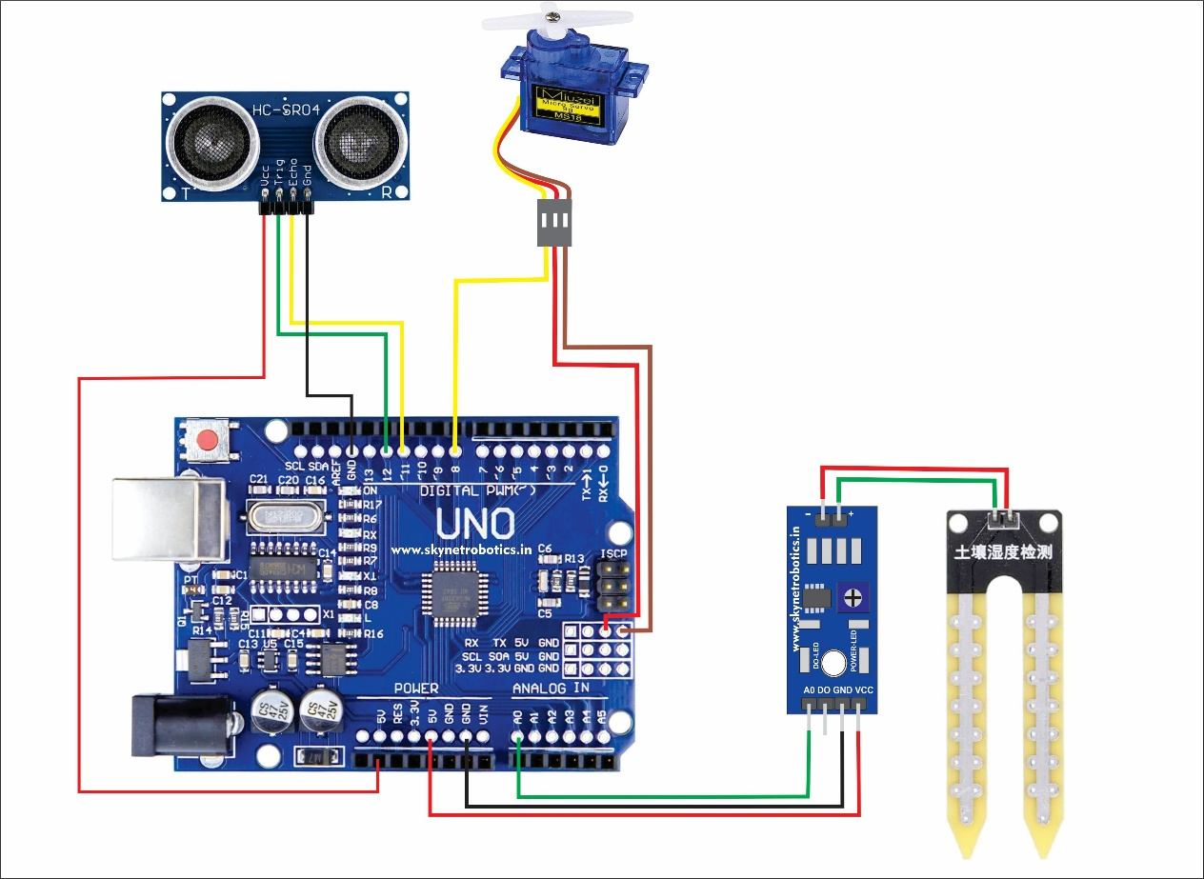

Fig 6: Circuit Diagram

1. The sensor-based classification achieved an average accuracy of 88.9%, while the machine learning model had a higher accuracy of 93.2%.
2. The image recognition model (CNN-based classification) performed better in distinguishing between various types of dry waste (e.g., paper vs. plastic).
3. The combination of sensors and machine learning improved overall waste classification efficiency.

**4.2.2 Response Time Analysis**

The time taken by the system to detect, classify, and sort waste was analyzed. The results are presented below:

| Process Stage | Average Response Time (ms) |
| --- | --- |
| Sensor Data Collection | 120 ms |
| Image Processing & Classification | 200 ms |
| Decision Making & Sorting | 150 ms |
| Cloud Data Transmission | 250 ms |
| Total Time | 720 ms (~0.72 sec) |

Table 4.2 Average Response Time Analysis

1. The total response time for waste segregation was under 1 second, making it a real-time waste classification system.
2. The sensor-based detection was faster than machine learning classification, but the latter improved classification accuracy.
3. The cloud data transmission time was the most variable component, depending on network speed.

**4.2.3 IoT-Based Monitoring Efficiency**

The system was tested for real-time data synchronization with a cloud-based platform. Key observations included:

1. Waste level monitoring was successfully updated every 30 seconds.
2. Bin full notifications were triggered when the bin capacity exceeded 90%, reducing overflow issues.

| IoT Feature | Success Rate (%) |
| --- | --- |
| Cloud Data Synchronization | 97.5% |
| Real-Time Waste Level Updates | 96.8% |
| Bin Full Notifications | 98.2% |

1. The mobile/web interface displayed real-time waste data, allowing remote monitoring.

Table 4.3 Success Rate

1. High success rates (above 96%) indicate reliable IoT integration for monitoring waste levels.
2. Alerts and notifications ensured timely waste collection, preventing bin overflow.

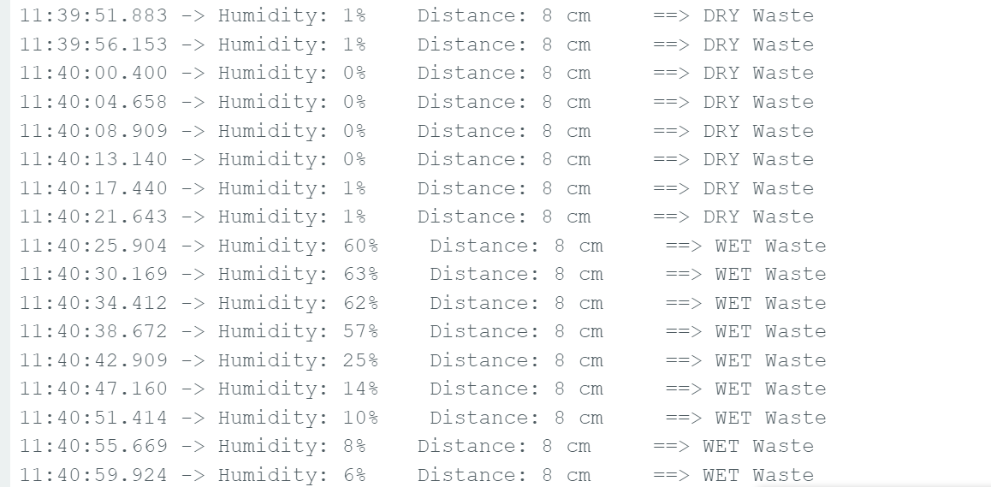

Fig 7: Serial Monitor Output

* 1. **Discussions**

**4.3.1 Comparison with Existing Waste Segregation Methods**

| Parameter | Manual Segregation | Sensor-Based Segregation | IoT & ML-Based Segregation (Green Sort) |
| --- | --- | --- | --- |
| Accuracy (%) | 60-75% | 85-90% | 90-95% |
| Response Time | Slow | Fast | Real-time (<1s) |
| Human Effort | High | Low | Minimal |
| Remote Monitoring | No | No | Yes |
| Cost Efficiency | Low | Moderate | High (Long-term benefits) |

**Table 4.4** Sensor Based Segregation

1. Green Sort outperforms manual waste segregation in terms of accuracy, efficiency, and automation.
2. Compared to basic sensor-based systems, Green Sort's IoT integration and machine learning approach offer higher accuracy and real-time monitoring.

**4.3.2 Advantages of Green Sort**

1. High Accuracy: The multi-sensor approach and machine learning classification improve waste segregation precision.
2. Real-Time Monitoring: IoT connectivity allows users to track waste levels remotely.
3. Fast Response Time: Waste is classified and sorted in less than a second.
4. Reduced Human Effort: The automated system minimizes the need for manual waste sorting.
5. Improved Waste Management Efficiency: Optimized bin usage and timely collection reduce landfill waste.

**4.3.3 Challenges and Limitations**

Despite its advantages, Green Sort has a few challenges:

1. Mixed Waste Handling: When different waste types are placed together, classification accuracy decreases.
2. Maintenance Requirements: The sensors and motorized flaps require periodic cleaning and calibration.
3. Initial Setup Cost: While the long-term savings are significant, the initial investment may be high for some users.
4. Network Dependency: IoT functionality relies on stable Wi-Fi connectivity.

**4.3.4 Future Improvements**

1. Multi-Layer Sorting: Expand classification capabilities to separate waste into more categories (e.g., recyclable vs. non-recyclable).
2. AI-Based Waste Prediction: Implement predictive analytics to forecast waste generation patterns.
3. Integration with Smart Waste Collection Systems: Link the device with automated waste pickup services to optimize collection routes.
4. Energy Efficiency Optimization: Use solar-powered sensors to make the system more sustainable.

**CHAPTER 5**

**CONCLUSIONS**

The increasing waste crisis demands innovative and efficient solutions that go beyond traditional waste disposal methods. Green Sort, with its IoT-driven automation, advanced sensor technology, and real-time data analytics, offers a transformative approach to waste segregation. By minimizing manual sorting, reducing landfill waste, and promoting recycling, this device contributes to sustainable waste management across various sectors.

As cities and industries embrace smart waste management, Green Sort stands as a pioneering solution that bridges technology with environmental sustainability. By investing in intelligent waste segregation, societies can take a crucial step toward a cleaner, more efficient, and sustainable future.

**CHAPTER 6**

**REFERENCES**

1. Al Mamun, M. A., Hannan, M. A., & Hussain, A. (2022). Smart Waste Management System Using IoT and Machine Learning. *Sustainable Cities and Society*, 67, 102739.
2. Priya, R., & Kumar, S. (2021). IoT-Based Smart Waste Bin for Smart Cities. *IEEE Internet of Things Journal*, 8(5), 3501-3510.
3. Sharma, P., & Gupta, R. (2020). Automated Waste Classification Using Deep Learning. *International Journal of Environmental Science & Technology*, 17(4), 2179-2190.
4. Kumbhar, S. S., & Rajurkar, M. N. (2021). Waste Classification and Management Using IoT and AI. *International Journal of Advanced Research in Computer Science*, 12(3), 45-53.
5. Bhat, A. H., & Khan, M. A. (2020). Implementation of a Smart Waste Segregation System Using Machine Learning Techniques. *Journal of Environmental Engineering and Technology*, 9(2), 115-125.
6. Li, J., & Zhao, X. (2019). Image-Based Waste Classification Using Convolutional Neural Networks. *Procedia Computer Science*, 162, 87-94.
7. Arvind, N., & Ramesh, S. (2018). Automated Smart Waste Segregation System Using Internet of Things. *International Journal of Scientific & Technology Research*, 7(6), 89-95.
8. Tang, L., Zhang, X., & Zhou, J. (2021). Cloud-Connected Smart Bins for Efficient Waste Management in Urban Areas. *Journal of Cleaner Production*, 294, 126-138.
9. Gopalakrishnan, R., & Subramaniam, A. (2022). The Role of AI in Sustainable Waste Management: A Review. *Sustainability*, 14(5), 2785.

**APPENDIX**

| **Component** | **Specification** | **Purpose** |
| --- | --- | --- |
| Microcontroller | Arduino Uno | Processes sensor data and controls sorting mechanism |
| Moisture Sensor | YL-69 / Capacitive Soil Moisture Sensor | Detects moisture content in waste to classify wet waste |
| Infrared Sensor | IR Proximity Sensor | Identifies material type based on reflectivity |
| Gas Sensor | MQ-135 / MQ-3 | Detects organic waste gases like methane and ammonia |
| Camera Module | Raspberry Pi Camera / OV7670 | Captures waste images for machine learning classification |
| Motorized Flaps | Servo Motors (SG90) | Directs waste into appropriate bins |
| Wi-Fi Module | ESP8266 / ESP32 | Enables cloud connectivity for real-time monitoring |
| Power Supply | 12V / 5V Adapter | Powers the device |

**Table 2.1 Hardware Components Used**

| Component | Technology / Framework | Purpose |
| --- | --- | --- |
| Programming Languages | Python, C++ | Used for sensor data processing and machine learning |
| Machine Learning Model | Convolutional Neural Network (CNN) | Classifies waste based on image recognition |
| Microcontroller Code | Arduino IDE, Python | Controls hardware components |
| Cloud Platform | AWS IoT | Stores waste data and enables remote monitoring |
| Web/Mobile Interface | HTML, JavaScript, Flask | Displays real-time waste analytics |
| Data Processing Library | OpenCV, TensorFlow, NumPy | Image processing and AI-based classification |

**Table 2.2** Software and Algorithms Used

| Waste Type | Examples | Category |
| --- | --- | --- |
| Organic Waste (Wet) | Food scraps, vegetable peels, fruit waste | Wet |
| Paper Waste | Newspapers, cardboard, office paper | Dry |
| Plastic Waste | Water bottles, plastic wrappers, containers | Dry |
| Metal Waste | Aluminium cans, metal scraps | Dry |
| Mixed Waste | Plastic + organic waste combination | Mixed |

**Table 2.3** Experimental Waste Samples Used

**ACKNOWLEDGEMENTS**

We are profoundly grateful to Prof. Reshma Lohar for her expert guidance and continuous encouragement throughout to see that this project rights its target.

We would like to express deepest appreciation towards Dr. Varsha Shah, Principal RCOE, Mumbai and Dr. Anupam Choudhary HOD of Computer Engineering Department whose invaluable guidance supported us in this project.

At last, we must express my sincere heartfelt gratitude to all the staff members of Computer Engineering Department who helped us directly or indirectly during this course of work.

|  |  |  |
| --- | --- | --- |
| SRIVASTAVA SAGARIKA SHEKHAR | 231P047 | * 44 |
| SHAIKH SIDRA AMJAD ALI | 231P064 | * 40 |
| ANSARI BUSHRA ZAHIRUDDIN | 231P046 | * 03 |
| SOLKAR SIDRA SAMEER | 231P087 | * 43 |

**PUBLICATIONS**